GAINSKEEPER
BasisPro
USER MANUAL

© 2006 Wolters Kluwer Financial Services, Inc. All Rights Reserved

Table of Contents
Copyrights 1
Introduction 2
1. Getting Started 3
1.1. Enter Parameters 3
1.2. Trade Entry 3
1.3. Cost Basis Report Review 6
2. Additional Functionality 8
2.1. Identifier Lookup 8
2.2. Track Back 9
2.3. Price Lookup 10
2.4. Email to Client 11
3. Account Information 13
3.1. My Account 13
3.2. Contact Us 16

Copyrights
This document is protected under the copyright laws of the United States. Any other use or disclosure in whole or in part of this information without the express written permission of GainsKeeper is prohibited.

Introduction
The GainsKeeper BasisPro system is designed to determine the cost basis of individual buy lot purchases. However, should multiple buy lots and subsequent partial sells be entered for the same security, FIFO will be applied to determine basis on any remaining shares. All transaction data must be entered either manually or imported via the Data Import function.

This guide contains the following sections:
- Getting Started
- Additional Functionality
- Account Information

Getting Started

Enter Parameters
When you import or manually record your transactions into the BasisPro system, you can define the following parameters:
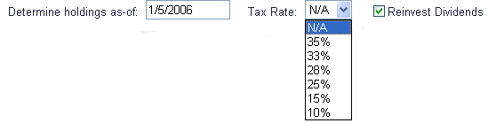

- Holding Date (Required) – This is the date on which you want to determine the cost basis for your security. The date entered must be after the original lot purchase date, and cannot be greater than the current date.
- Tax Rate – Select a specific tax rate from the Tax Rate drop-down menu. If a tax rate does not apply, select N/A.
- Reinvest Dividends – You can reinvest dividends to buy additional shares instead of receiving a cash payout. To automatically reinvest dividends, select the Reinvest Dividends checkbox.

Trade Entry

Manually Enter Trades
Use this section to manually enter your original lot purchase information and subsequent partial sells. Below is an example of the Data Input screen, as well an explanation of the information that needs to be entered in each field.
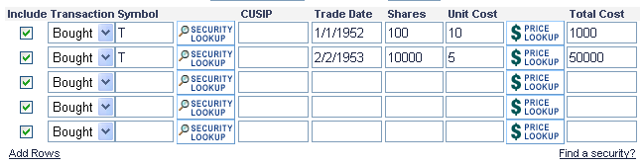
- Include – Selecting this checkbox indicates the transaction you want to include in the calculation.
- Transaction – Indicates the transaction type by selecting either Bought or Sold.
- Symbol – Enter the security symbol (this is not required if the CUSIP is entered). If you do not know the security symbol, use the Security Lookup feature.
- CUSIP – Enter the security CUSIP (this is not required if the Symbol is entered).
- Trade Date – Enter the Trade Date of the Buy Lot Purchase and/or subsequent Partial Sells.
- Shares – Enter the number of shares bought or sold.
- Unit Cost – Enter the purchase or sale price per share plus any fees and/or commission. If you do not know the unit cost, use the Price Lookup feature.
Note: There is no need to enter this data if you are using the Total Cost field.
- Total Cost – Enter the total cost of the lot bought or sold.

Add Rows
There are 5 rows shown in the Data Input table for entering your lot information. If you need additional rows, click the Add Rows link and 5 additional rows will be added at the bottom of the table.

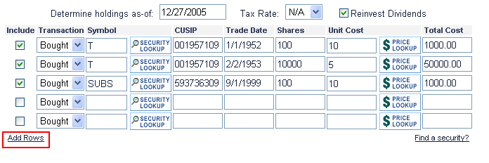

Bulk Import
Multiple purchase lots and sells can be imported into the BasisPro data input screen from an Excel spreadsheet. Click here to view the procedure for importing trades.

Trade Storage – My Trades
The My Trades drop-down menu enables you to do the following with your data:
- Save New
- Import Data
- Select Previously Saved Data

Save New
Select [Save New] from the My Trades drop-down list to save the information you currently have entered in the Data Input screen. If you select this option, a blank field displays next to the My Trades drop-down list. Enter a name for the trades and click Save Trades. The new data set is added to the My Trades list.

Import Data
To import trades into BasisPro, do the following:
- From the My Trades drop-down menu, select [Import Data].
- Download the Excel Template.
- Populate the Excel file with your purchase and sell information and save it to your local PC.
- Select the Excel file to be imported.
- Import the file by clicking the Import File button.
- View your cost basis by click the Analyze button

Select Previously Saved Data
To view your previously saved data, select the appropriate name from the My Trades drop-down list and the data input screen for that selection is displayed. To automatically fill in trade information, click the Update button. For example, if you have entered the number of shares and the unit cost, the Total Cost field will automatically be populated when you click the Update button. To remove the saved trades from the My Trades drop-down list, click the Delete button.

Cost Basis Report Review

View Cost Basis Results
The Cost Basis Results screen displays your original lot acquisition and all subsequent sell information that was entered into the Data Input screen. All corporate actions that affected the original lot are automatically applied to determine the resulting shares and cost basis on the specific holding date. Once you have completed entering or importing all of your lot information to the Data Input screen, click Analyze to view the cost basis report. This report screen contains the following sections.
- Original Positions – This section highlights your position as of the original purchase date.
- Cost Basis Details – This section highlights your cost basis as of the date you entered in the Determine Holdings as-of date field.
- Realized Gain/Loss Details – This section highlights your gains and/or losses as of the Determine Holding as-of date.
- Corporate Action Summary – This section highlights the corporate actions that have occurred and the impact they had on your cost basis.

Below is an example of the Cost Basis Results screen:

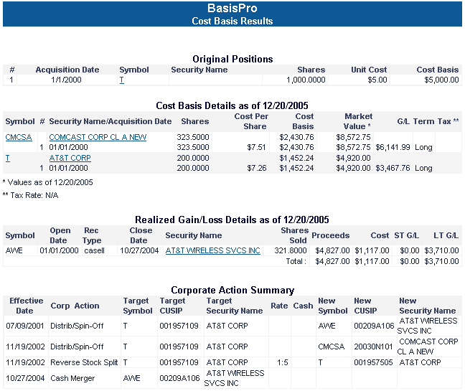

Symbol History
You can view the transaction history for a security using the Symbol History feature. To view transaction history, do one of the following from the Cost Basis Results screen:
- Click the Symbol link in the Original Positions section.
- Click the Symbol link in the Cost Basis Details section
- Click the Security Name/Acquisition Date link in the Cost Basis Details section.
- Click the Security Name link in the Realized Gain/Loss Details section.

Export Results
You can export your cost basis results to another format from the Cost Basis Results page. Select an export format by clicking the appropriate link at the top of the Cost Basis Results page. Once you click a link, you are given the option to open the file, or save it to your computer. Export format options include:
- Export to Excel
- Export to PDF

Additional Functionality

Identifier Lookup
If you are unsure of the symbol or CUSIP for a specific lot, you can search for it using the Identifier Look-up feature.
    - To access the Identifier Look-up feature, do one of the following:
- Click the Find a Security? link.
- Click the Security Lookup icon next to the Symbol field.
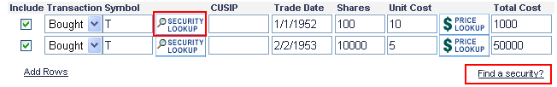
- Once the Security Research Center screen displays, enter a keyword in the Identifier Look-up field and click Search. The CUSIP and Symbol for the security name are displayed.
- Click the Select link next to the appropriate security. This closes the Security Research Center screen and populates the Data Input screen with the selected security information.

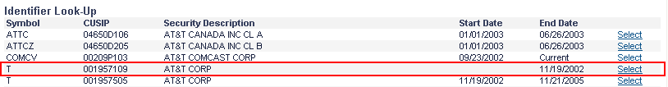

Track Back
If you are unsure of the origin of a position, you can use the Track Back feature. This screen enables you to enter a symbol or CUSIP and see all of the corporate actions that may have created the position.
    - To access the Track Back feature, do one of the following:
- Click the Find a Security? link.
- Click the Security Lookup icon next to the Symbol field.
  - Once the Security Research Center screen displays, enter a symbol or CUSIP in the Track Back field. Then, enter a date to track back from and click Search. The corporate actions that occurred and resulted in shares of the security for which you performed the search are displayed.
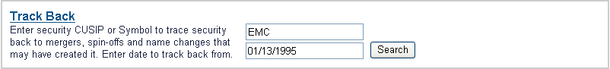
    - Click the Select link next to the appropriate corporate action. This closes the Security Research Center screen and populates the Data Input screen with the symbol and CUSIP for the selected corporate action.

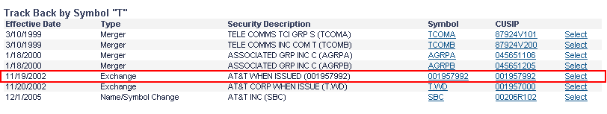

Price Lookup
When entering trades into the Data Input screen, you can use the Price Lookup feature to search for the price of a security. To use this feature, enter the Security Symbol or the CUSIP of the security and the Trade Date. Once you have entered this information, click the Price Lookup icon and the price of the security, as of the specified trade date, is populated in the Unit Cost field.

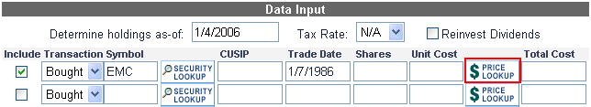

Email to Client
You can email the cost basis results to a client by clicking the Email to Client button at the bottom of the Cost Basis Results screen. This displays the Email Creation page. Once you have entered the required information on this page, click the Send Email button to send the email to the client. Below is an example of the information entry portion of this screen.

Complete the fields in this section for the recipient and the sender. If you would like to have a copy of the email sent to you, select the Send copy to sender checkbox. You can also click the Printable Version link to access the email in a print format.

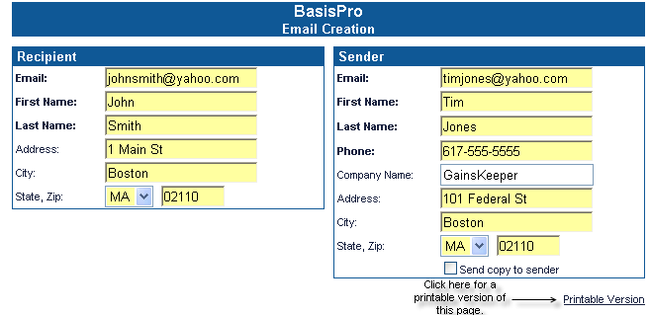

The Letter Header and the Letter Footer are populated by default. You can edit this information to include any specifics you would like to send to the client.
Note: The Corporate Action detail is omitted from emails that are being sent to clients.

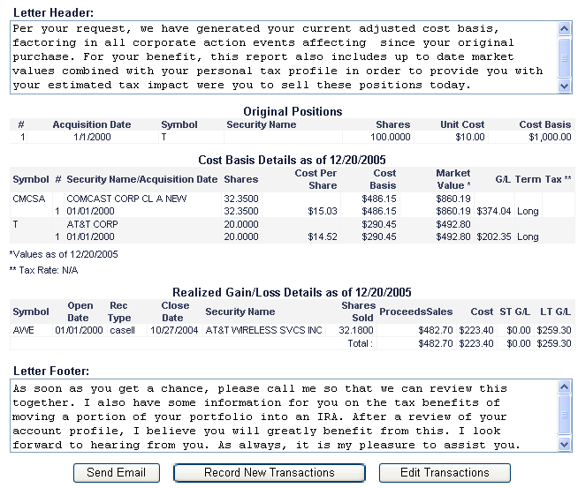

Record New Transactions
To create new transactions, click the Record New Transactions button from the Email Creation screen. You are taken back to a blank Data Input screen where you can record and save new transactions.

Edit Transactions
To edit existing transactions, click the Edit Transactions button from the Email Creation screen. The Data Input screen displays and contains the last group of transactions that were being analyzed.

Account Information

My Account
The My Account page displays a brief overview of your account. From this page, you can perform the following actions:
- Change Login ID and/or Password
- Edit Owner Info
Below is an example of the My Account page. To access this page, click the My Account link on top navigation bar of any page.
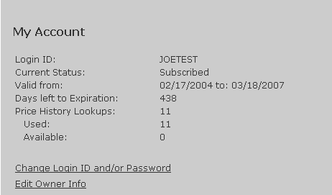

Change Login ID and/or Password
To change your login information in BasisPro, click the Change Login ID and/or Password link on the My Account page. The page that displays contains your current login ID. To change this, enter a new login ID in the Login ID field. To update your password, enter your old password and a new password. Confirm the new password by entering the new password in the Confirm New Password field. In the event you lose your password, you would need to answer a security question in order to access your account. Select one of the displayed security questions and type your answer to the question in the Security Answer field. Click Submit to save and update your login ID and password information. To close this screen without saving the information, click Cancel.
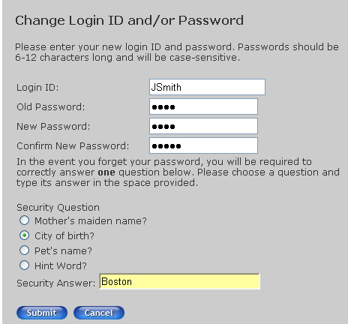

Edit Owner Info
To edit owner information, click the Edit Owner Info link on the My Account page. Select the name of the owner to edit from the Select owner to edit drop-down list. Once you have selected the appropriate owner, make any desired changes and click Submit to save the changes. To close the window without saving your changes, click Cancel.

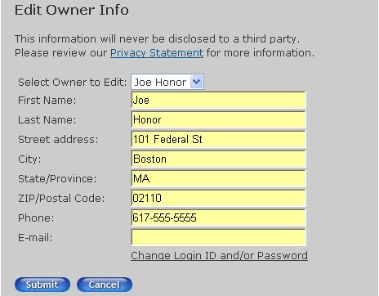

Contact Us
If you would like to contact GainsKeeper directly regarding your account, click the Contact Us link at the top of any page in BasisPro. This displays a list of contact email addresses. Click the link under Product Support and the Feedback page displays. Your email address defaults in the Your Email field. Select a Category for your question and type a subject for the email. Type your question in the Comment/Question field and click Submit to send your question to GainsKeeper Product Support. To close this screen, without sending your question, click Cancel.

